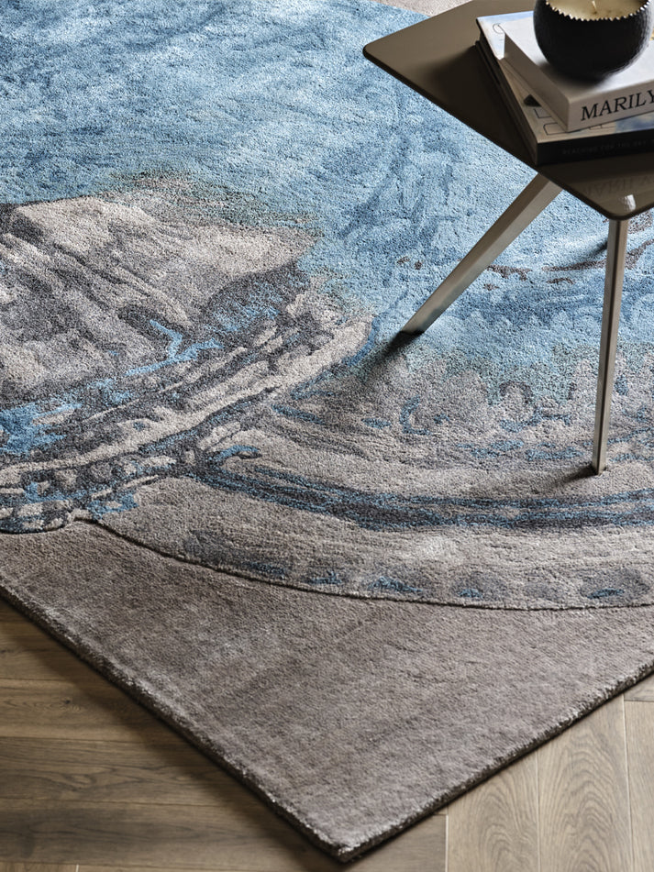

$2,430.00

BLOOMBELL Prussian  
Hand Tufted, 100% Botanical Silk

Collection:[Antonym](https://handscarpets.asia/collections/antonym)

Making Type: Hand Tufted

Material: 100% Botanical Silk